CHAPTER 2

TEACHING NOTES

This is the chapter where I expect students to follow most, if not all, of the algebraic derivations. In class I like to derive at least the unbiasedness of the OLS slope coefficient, and usually I derive the variance. At a minimum, I talk about the factors affecting the variance. To simplify the notation, after I emphasize the assumptions in the population model, and assume random sampling, I just condition on the values of the explanatory variables in the sample. Technically, this is justified by random sampling because, for example, E(u_{i}|x₁,x₂,…,x_{n}) = E(u_{i}|x_{i}) by independent sampling. I find that students are able to focus on the key assumption SLR.4 and subsequently take my word about how conditioning on the independent variables in the sample is harmless. (If you prefer, the appendix to Chapter 3 does the conditioning argument carefully.) Because statistical inference is no more difficult in multiple regression than in simple regression, I postpone inference until Chapter 4. (This reduces redundancy and allows you to focus on the interpretive differences between simple and multiple regression.)

You might notice how, compared with most other texts, I use relatively few assumptions to derive the unbiasedness of the OLS slope estimator, followed by the formula for its variance. This is because I do not introduce redundant or unnecessary assumptions. For example, once SLR.4 is assumed, nothing further about the relationship between u and x is needed to obtain the unbiasedness of OLS under random sampling.

SOLUTIONS TO PROBLEMS

2.1 (i) Income, age, and family background (such as number of siblings) are just a few possibilities. It seems that each of these could be correlated with years of education. (Income and education are probably positively correlated; age and education may be negatively correlated because women in more recent cohorts have, on average, more education; and number of siblings and education are probably negatively correlated.)

(ii) Not if the factors we listed in part (i) are correlated with educ. Because we would like to hold these factors fixed, they are part of the error term. But if u is correlated with educ then E(u|educ) ≠ 0, and so SLR.4 fails.

2.2 In the equation y = β₀ + β₁x + u, add and subtract α₀ from the right hand side to get y = (α₀ + β₀) + β₁x + (u − α₀). Call the new error e = u − α₀, so that E(e) = 0. The new intercept is α₀ + β₀, but the slope is still β₁.

2.3 (i) Let y_{i} = GPA_{i}, x_{i} = ACT_{i}, and n = 8. Then = 25.875, = 3.2125, 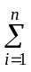(x_{i} – )(y_{i} – ) = 5.8125, and (x_{i} – )² = 56.875. From equation (2.9), we obtain the slope as 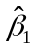= 5.8125/56.875 .1022, rounded to four places after the decimal. From (2.17), 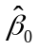 = – 3.2125 – (.1022)25.875 .5681. So we can write

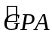 = .5681 + .1022 ACT
n = 8.

The intercept does not have a useful interpretation because ACT is not close to zero for the population of interest. If ACT is 5 points higher, increases by .1022(5) = .511.

(ii) The fitted values and residuals — rounded to four decimal places — are given along with the observation number i and GPA in the following table:

i | GPA
1 | 2.8 | 2.7143 | .0857
2 | 3.4 | 3.0209 | .3791
3 | 3.0 | 3.2253 | –.2253
4 | 3.5 | 3.3275 | .1725
5 | 3.6 | 3.5319 | .0681
6 | 3.0 | 3.1231 | –.1231
7 | 2.7 | 3.1231 | –.4231
8 | 3.7 | 3.6341 | .0659

You can verify that the residuals, as reported in the table, sum to −.0002, which is pretty close to zero given the inherent rounding error.

(iii) When ACT = 20, = .5681 + .1022(20) 2.61.

(iv) The sum of squared residuals, 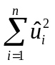, is about .4347 (rounded to four decimal places), and the total sum of squares, 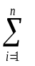(y_{i} – )², is about 1.0288. So the R-squared from the regression is

R² = 1 – SSR/SST 1 – (.4347/1.0288) .577.

Therefore, about 57.7% of the variation in GPA is explained by ACT in this small sample of students.

2.4 (i) When cigs = 0, predicted birth weight is 119.77 ounces. When cigs = 20, 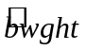 = 109.49. This is about an 8.6% drop.

(ii) Not necessarily. There are many other factors that can affect birth weight, particularly overall health of the mother and quality of prenatal care. These could be correlated with cigarette smoking during birth. Also, something such as caffeine consumption can affect birth weight, and might also be correlated with cigarette smoking.

(iii) If we want a predicted bwght of 125, then cigs = (125 – 119.77)/( –.524) –10.18, or about –10 cigarettes! This is nonsense, of course, and it shows what happens when we are trying to predict something as complicated as birth weight with only a single explanatory variable. The largest predicted birth weight is necessarily 119.77. Yet almost 700 of the births in the sample had a birth weight higher than 119.77.

(iv) 1,176 out of 1,388 women did not smoke while pregnant, or about 84.7%. Because we are using only cigs to explain birth weight, we have only one predicted birth weight at cigs = 0. The predicted birth weight is necessarily roughly in the middle of the observed birth weights at cigs = 0, and so we will under predict high birth rates.

2.5 (i) The intercept implies that when inc = 0, cons is predicted to be negative $124.84. This, of course, cannot be true, and reflects that fact that this consumption function might be a poor predictor of consumption at very low-income levels. On the other hand, on an annual basis, $124.84 is not so far from zero.

(ii) Just plug 30,000 into the equation: 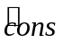 = –124.84 + .853(30,000) = 25,465.16 dollars.

(iii) The MPC and the APC are shown in the following graph. Even though the intercept is negative, the smallest APC in the sample is positive. The graph starts at an annual income level of $1,000 (in 1970 dollars).

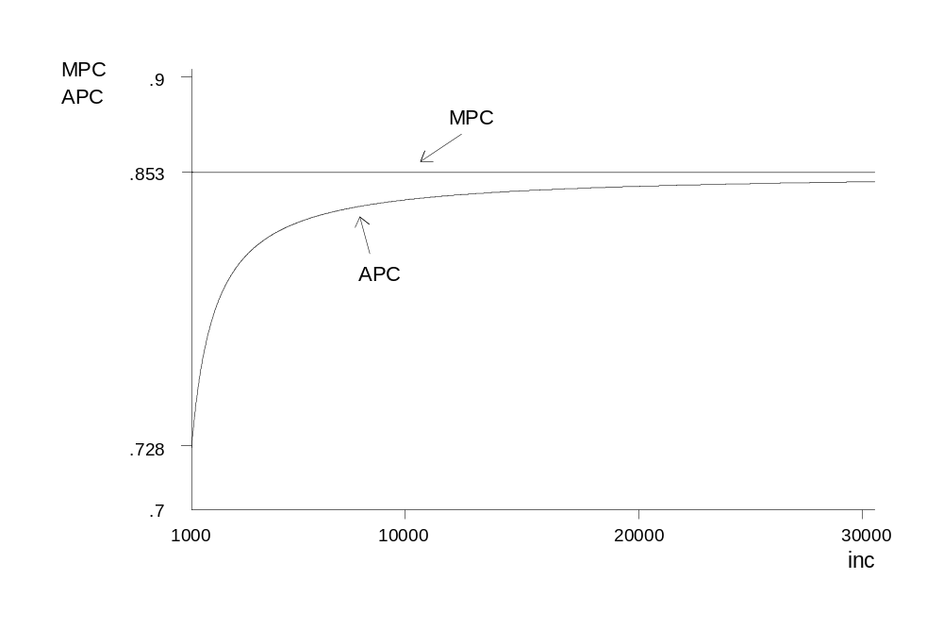
2.6 (i) Yes. If living closer to an incinerator depresses housing prices, then being farther away increases housing prices.

(ii) If the city chose to locate the incinerator in an area away from more expensive neighborhoods, then log(dist) is positively correlated with housing quality. This would violate SLR.4, and OLS estimation is biased.

(iii) Size of the house, number of bathrooms, size of the lot, age of the home, and quality of the neighborhood (including school quality), are just a handful of factors. As mentioned in part (ii), these could certainly be correlated with dist [and log(dist)].

2.7 (i) When we condition on inc in computing an expectation, 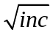 becomes a constant. So E(u|inc) = E(e|inc) = E(e|inc) = 0 because E(e|inc) = E(e) = 0.

(ii) Again, when we condition on inc in computing a variance, becomes a constant. So Var(u|inc) = Var(e|inc) = ()²Var(e|inc) = 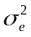inc because Var(e|inc) = .

(iii) Families with low incomes do not have much discretion about spending; typically, a low-income family must spend on food, clothing, housing, and other necessities. Higher income people have more discretion, and some might choose more consumption while others more saving. This discretion suggests wider variability in saving among higher income families.

2.8 (i) From equation (2.66),

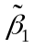 = 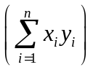 / 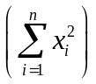.

Plugging in y_{i} = β₀ + β₁x_{i} + u_{i} gives

= 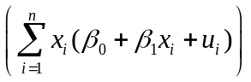/ .

After standard algebra, the numerator can be written as

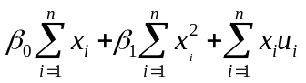.

Putting this over the denominator shows we can write as

= β₀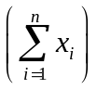/ + β₁ + 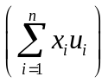/ .

Conditional on the x_{i}, we have

E() = β₀/ + β₁
because E(u_{i}) = 0 for all i. Therefore, the bias in is given by the first term in this equation. This bias is obviously zero when β₀ = 0. It is also zero when 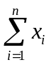 = 0, which is the same as = 0. In the latter case, regression through the origin is identical to regression with an intercept.
(ii) From the last expression for in part (i) we have, conditional on the x_{i},

Var() = 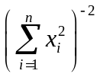Var = 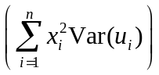
= 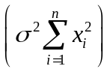 = / .

(iii) From (2.57), Var() = σ²/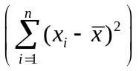. From the hint, 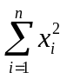 ≥ 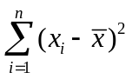, and so Var() ≤ Var(). A more direct way to see this is to write = 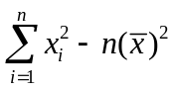, which is less than unless = 0.
(iv) For a given sample size, the bias in increases as increases (holding the sum of the 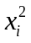 fixed). But as increases, the variance of increases relative to Var(). The bias in is also small when 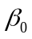 is small. Therefore, whether we prefer or on a mean squared error basis depends on the sizes of , , and n (in addition to the size of ).

2.9 (i) We follow the hint, noting that 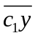 = 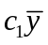 (the sample average of 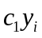 is c₁ times the sample average of y_{i}) and 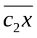 = 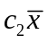. When we regress c₁y_{i} on c₂x_{i} (including an intercept) we use equation (2.19) to obtain the slope:

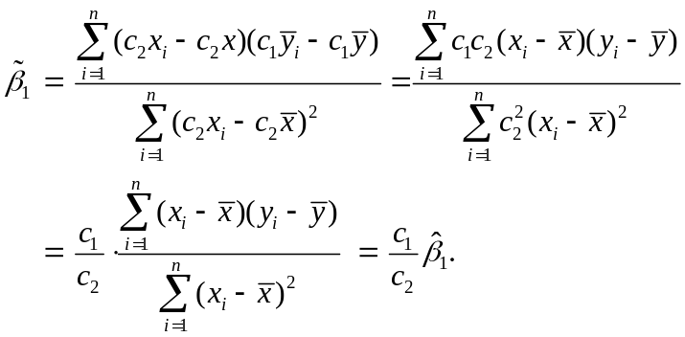
From (2.17), we obtain the intercept as 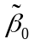 = (c₁) – (c₂) = (c₁) – [(c₁/c₂)](c₂) = c₁( – ) = c₁) because the intercept from regressing y_{i} on x_{i} is ( – ).

(ii) We use the same approach from part (i) along with the fact that 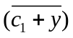 = c₁ + and 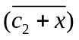 = c₂ + . Therefore, 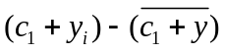 = (c₁ + y_{i}) – (c₁ + ) = y_{i} – and (c₂ + x_{i}) – = x_{i} – . So c₁ and c₂ entirely drop out of the slope formula for the regression of (c₁ + y_{i}) on (c₂ + x_{i}), and = . The intercept is = – = (c₁ + ) – (c₂ + ) = (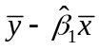) + c₁ – c₂ = + c₁ – c₂, which is what we wanted to show.

(iii) We can simply apply part (ii) because 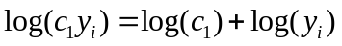. In other words, replace c₁ with log(c₁), y_{i} with log(y_{i}), and set c₂ = 0.

(iv) Again, we can apply part (ii) with c₁ = 0 and replacing c₂ with log(c₂) and x_{i} with log(x_{i}). If 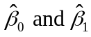 are the original intercept and slope, then 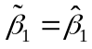 and 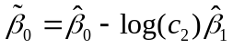.

2.10 (i) This derivation is essentially done in equation (2.52), once 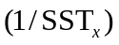 is brought inside the summation (which is valid because 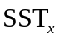 does not depend on i). Then, just define 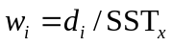.

(ii) Because 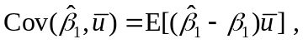 we show that the latter is zero. But, from part (i),
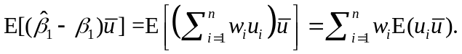 Because the 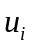 are pairwise uncorrelated (they are independent), 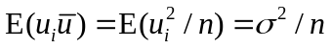 (because 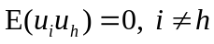). Therefore,

(iii) The formula for the OLS intercept is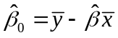 and, plugging in 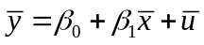 gives

(iv) Because 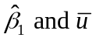 are uncorrelated,
,
which is what we wanted to show.

(v) Using the hint and substitution gives 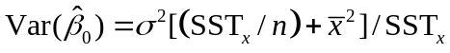

2.11 (i) We would want to randomly assign the number of hours in the preparation course so that hours is independent of other factors that affect performance on the SAT. Then, we would collect information on SAT score for each student in the experiment, yielding a data set 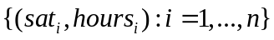, where n is the number of students we can afford to have in the study. From equation (2.7), we should try to get as much variation in 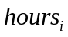 as is feasible.

(ii) Here are three factors: innate ability, family income, and general health on the day of the exam. If we think students with higher native intelligence think they do not need to prepare for the SAT, then ability and hours will be negatively correlated. Family income would probably be positively correlated with hours, because higher income families can more easily afford preparation courses. Ruling out chronic health problems, health on the day of the exam should be roughly uncorrelated with hours spent in a preparation course.

(iii) If preparation courses are effective,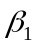 should be positive: other factors equal, an increase in hours should increase sat.

(iv) The intercept, 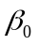, has a useful interpretation in this example: because E(u) = 0, is the average SAT score for students in the population with hours = 0.

SOLUTIONS TO COMPUTER EXERCISES

C2.1 (i) The average prate is about 87.36 and the average mrate is about .732.

(ii) The estimated equation is

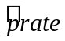= 83.05 + 5.86 mrate
n = 1,534, R² = .075.

(iii) The intercept implies that, even if mrate = 0, the predicted participation rate is 83.05 percent. The coefficient on mrate implies that a one-dollar increase in the match rate – a fairly large increase – is estimated to increase prate by 5.86 percentage points. This assumes, of course, that this change prate is possible (if, say, prate is already at 98, this interpretation makes no sense).

(iv) If we plug mrate = 3.5 into the equation we get 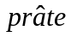= 83.05 + 5.86(3.5) = 103.59. This is impossible, as we can have at most a 100 percent participation rate. This illustrates that, especially when dependent variables are bounded, a simple regression model can give strange predictions for extreme values of the independent variable. (In the sample of 1,534 firms, only 34 have mrate ≥ 3.5.)

(v) mrate explains about 7.5% of the variation in prate. This is not much, and suggests that many other factors influence 401(k) plan participation rates.

C2.2 (i) Average salary is about 865.864, which means $865,864 because salary is in thousands of dollars. Average ceoten is about 7.95.

(ii) There are five CEOs with ceoten = 0. The longest tenure is 37 years.

(iii) The estimated equation is

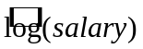= 6.51 + .0097 ceoten
n = 177, R² = .013.

We obtain the approximate percentage change in salary given Δceoten = 1 by multiplying the coefficient on ceoten by 100, 100(.0097) = .97%. Therefore, one more year as CEO is predicted to increase salary by almost 1%.

C2.3 (i) The estimated equation is

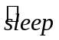= 3,586.4 – .151 totwrk
n = 706, R² = .103.

The intercept implies that the estimated amount of sleep per week for someone who does not work is 3,586.4 minutes, or about 59.77 hours. This comes to about 8.5 hours per night.

(ii) If someone works two more hours per week then Δtotwrk = 120 (because totwrk is measured in minutes), and so 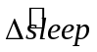= –.151(120) = –18.12 minutes. This is only a few minutes a night. If someone were to work one more hour on each of five working days, =
–.151(300) = –45.3 minutes, or about five minutes a night.

C2.4 (i) Average salary is about $957.95 and average IQ is about 101.28. The sample standard deviation of IQ is about 15.05, which is pretty close to the population value of 15.

(ii) This calls for a level-level model:

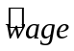 = 116.99 + 8.30 IQ
n = 935, R² = .096.

An increase in IQ of 15 increases predicted monthly salary by 8.30(15) = $124.50 (in 1980 dollars). IQ score does not even explain 10% of the variation in wage.

(iii) This calls for a log-level model:

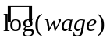= 5.89 + .0088 IQ
n = 935, R² = .099.

If ΔIQ = 15 then 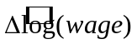 = .0088(15) = .132, which is the (approximate) proportionate change in predicted wage. The percentage increase is therefore approximately 13.2.

C2.5 (i) The constant elasticity model is a log-log model:

log(rd) = + 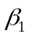log(sales) + u,

where is the elasticity of rd with respect to sales.

(ii) The estimated equation is

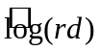= –4.105 + 1.076 log(sales)
n = 32, R² = .910.

The estimated elasticity of rd with respect to sales is 1.076, which is just above one. A one percent increase in sales is estimated to increase rd by about 1.08%.

C2.6 (i) It seems plausible that another dollar of spending has a larger effect for low-spending schools than for high-spending schools. At low-spending schools, more money can go toward purchasing more books, computers, and for hiring better qualified teachers. At high levels of spending, we would expend little, if any, effect because the high-spending schools already have high-quality teachers, nice facilities, plenty of books, and so on.

(ii) If we take changes, as usual, we obtain

just as in the second row of Table 2.3. So, if 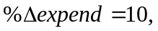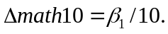

(iii) The regression results are
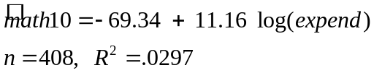

(iv) If expend increases by 10 percent, 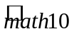 increases by about 1.1 percentage points. This is not a huge effect, but it is not trivial for low-spending schools, where a 10 percent increase in spending might be a fairly small dollar amount.

(v) In this data set, the largest value of math10 is 66.7, which is not especially close to 100. In fact, the largest fitted values is only about 30.2.

